**Name :- Vikash Yadav**

**Email Id – vikashyadav11185@gmail.com**

**College Name :- Maulana Azad National Institute of Technology Bhopal Madhya Pradesh**

**Git Assignment 1**

1. **Create a New Repository**

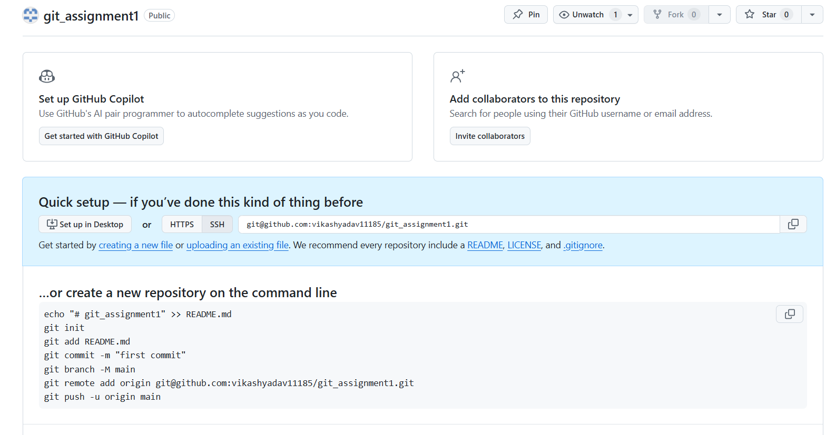

1. **Create a new file**

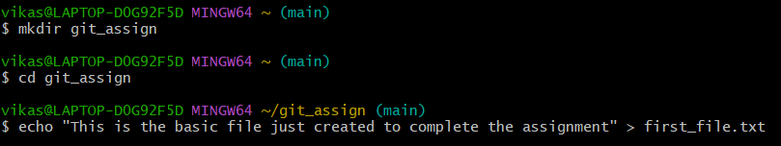

1. **Create a New Branch**

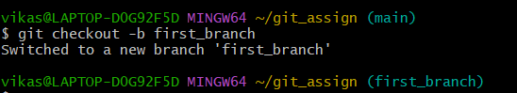

1. **Make Changes in the new Branch**

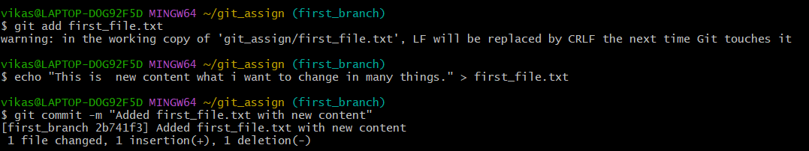

1. **Create Another Branch**

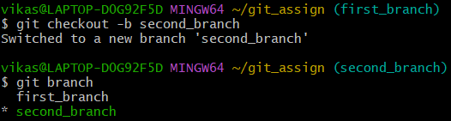

1. **Merge Branches**

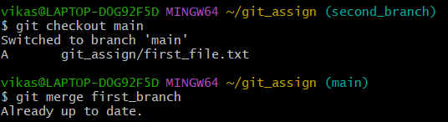

1. **Pull changes from remote**

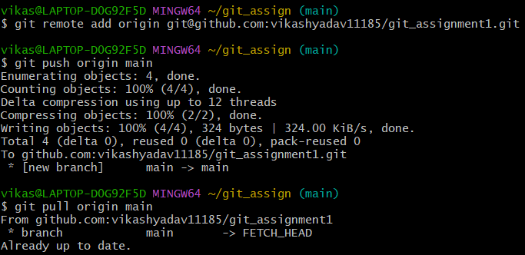

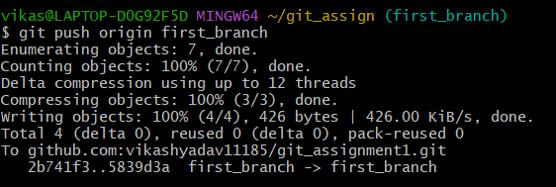

1. **View Git Log and History**

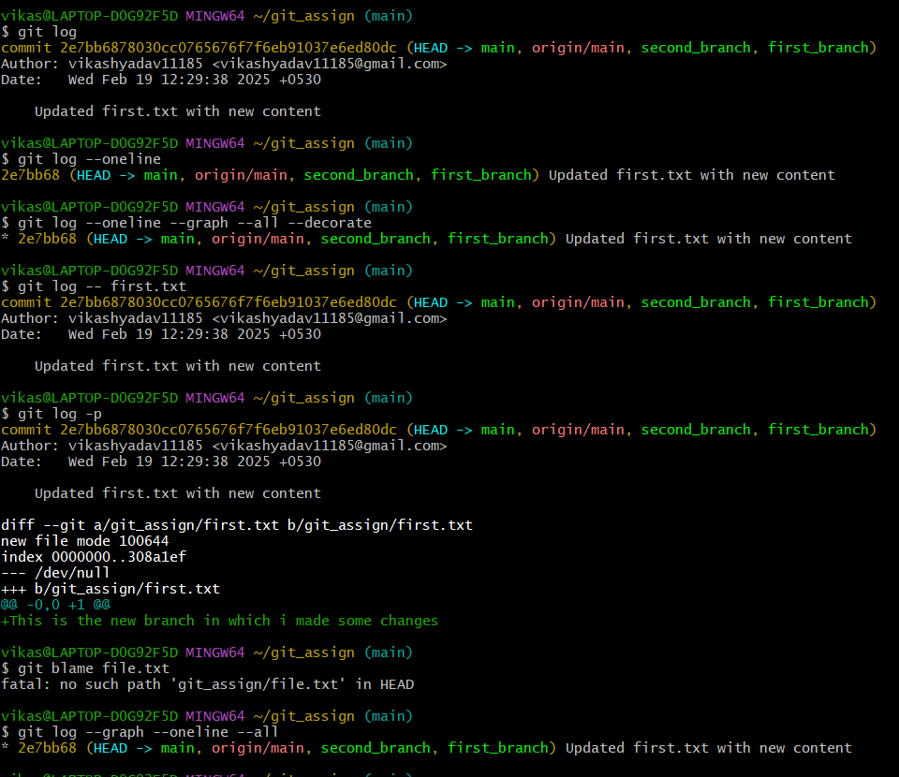

1. **Git Status and Staging**

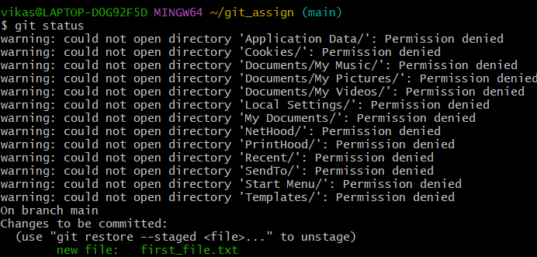

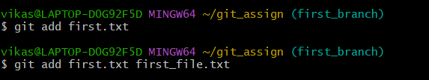

1. **Revert and Reset**

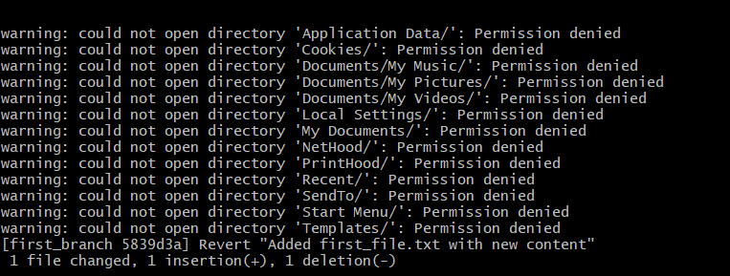

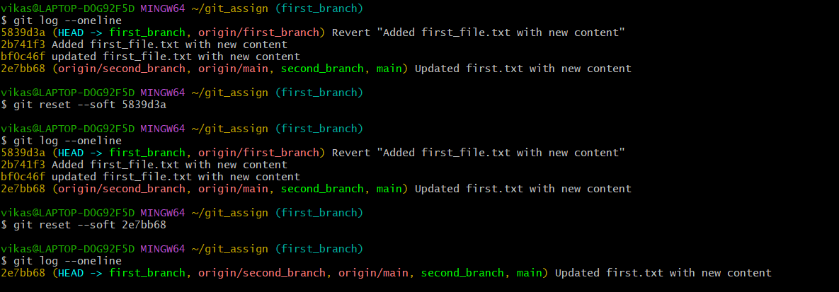

**Extra Screenshots of repository and their changes**

